freETarget
Application Note: Resetting a Target Board

INTRODUCTION
In some cases, updating the software on a FreeETarget will cause the board to appear disabled or broken. This is because when going from an old to new version, the board needs to be reinitialized. This is a simple three step process.
RESETTING THE BOARD
1 – Connect to the target using the PC Client
2 - Start the Debug Terminal using the ESP32 Icon.
Red Fingerprint 
3 – End the Self Test
You will observe the target repetitively sending a list of numbers as shown below.
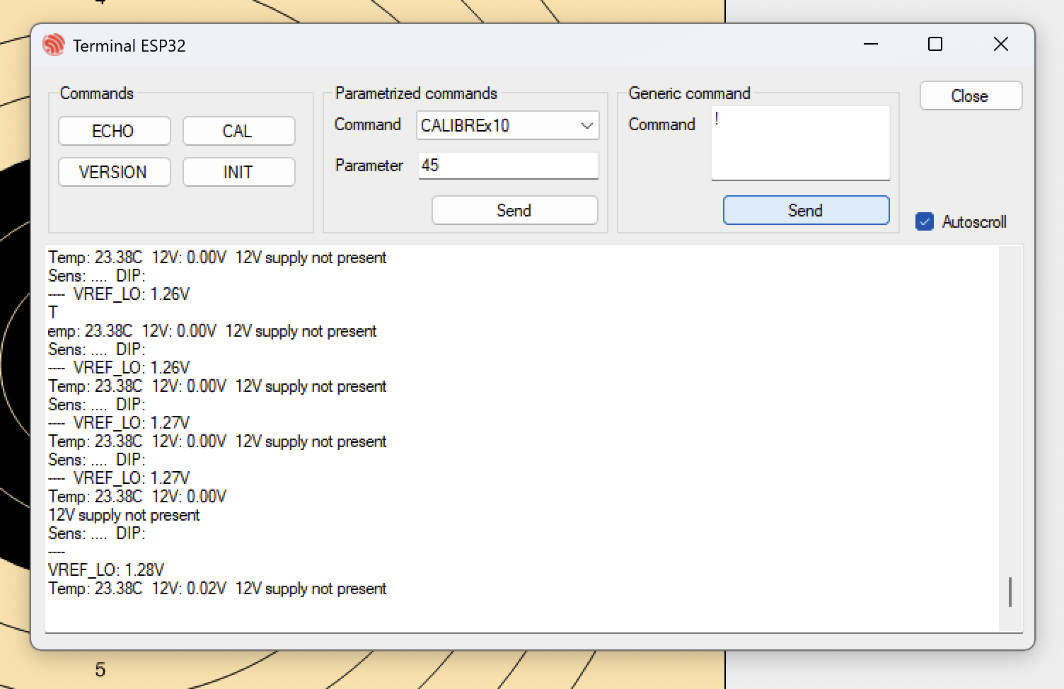
Enter an ! (exclamation mark) in the Generic Command box and press SEND

4 – Provide a serial number
The test will end and you will be prompted to enter a serial number
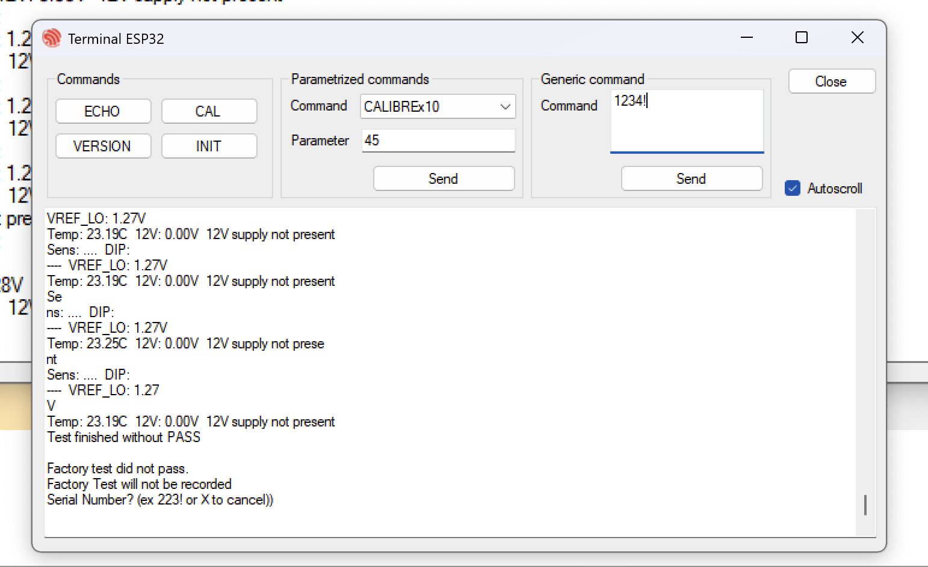
In the Generic Command box enter the serial number printed on the circuit board.
Add an exclamation mark to the end of the serial number and press SEND. (Example 1234!)
5 – The test will end and the target go into service
